|  |  |
| --- | --- |
| Assignment Date | 11-11-2022 |
| Student Name | SINDHU.M |
| Student Roll Number | 812419104062 |
| Maximum Marks | 2 Marks |
| TEAM ID | TNT2022TMID45363 |

s

Question 1:

Pull an image from docker hub and run it in docker playground.

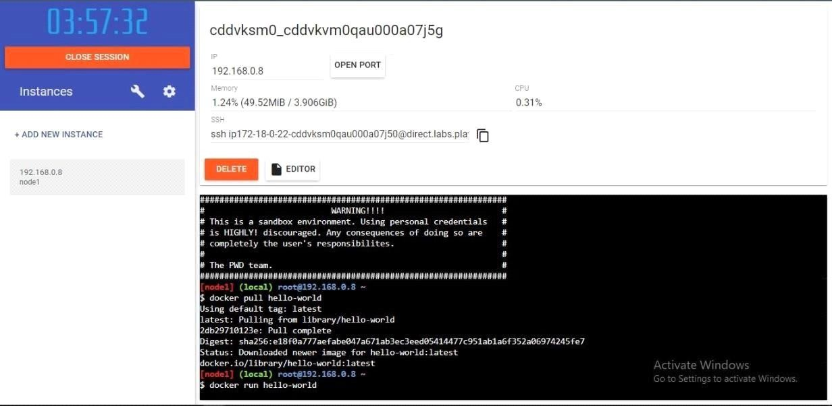

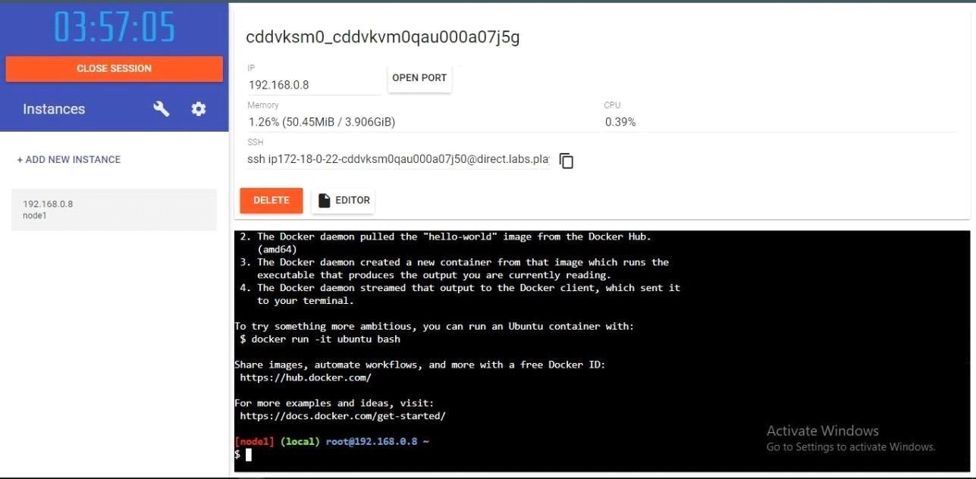

Question 2:

Create a docker ﬁle for the jobportal application and deploy it in Docker desktopapplication.

DOCKERFILE:

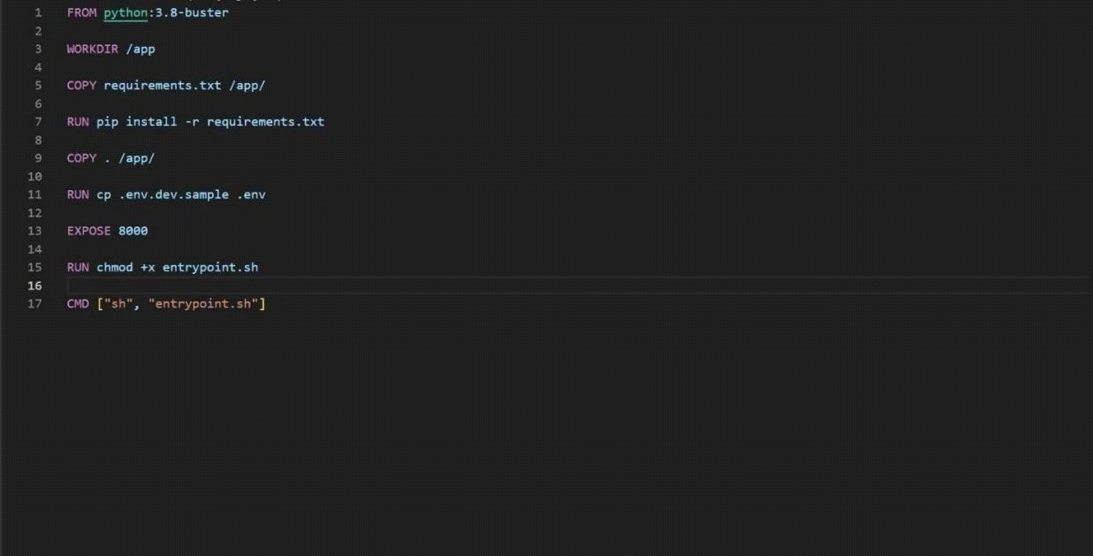

DEPLOYMENT OF JOBPORTAL APPLICATION:

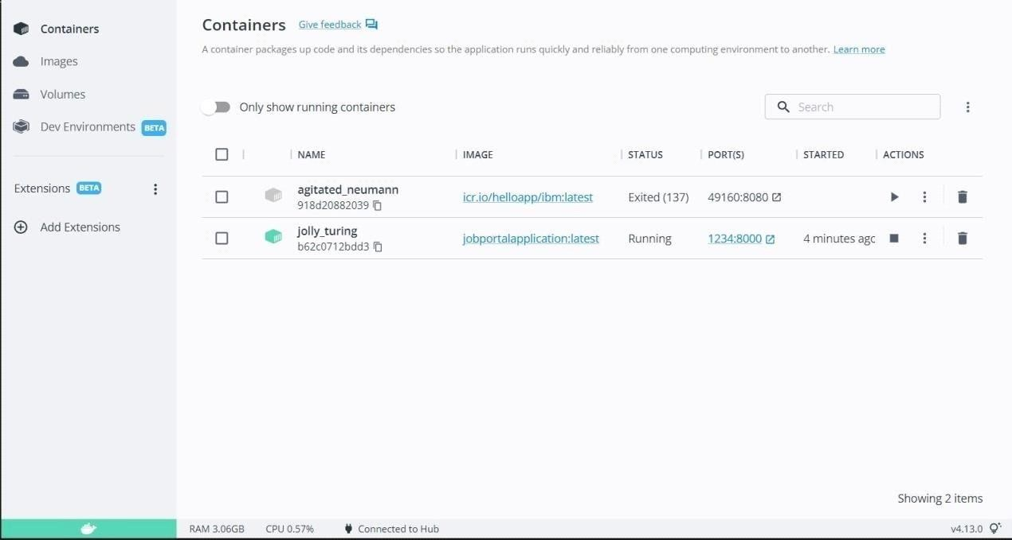

OUTPUT:

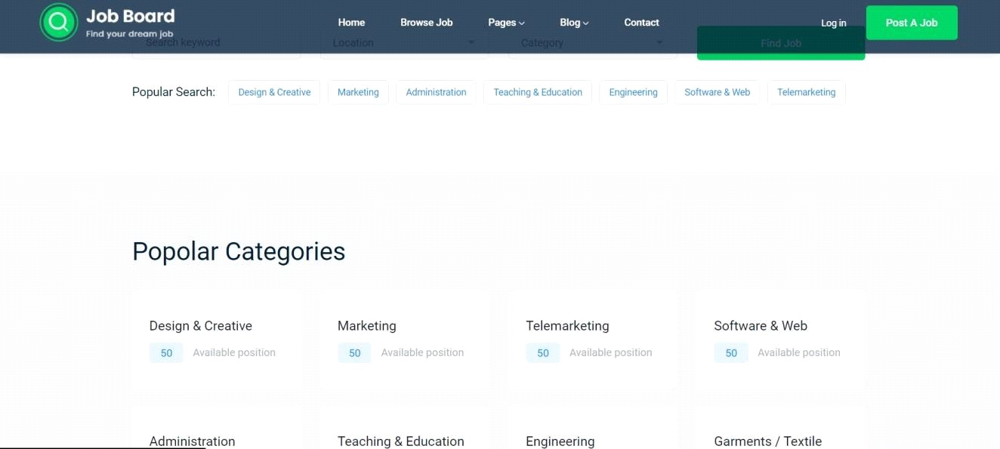

Question 3:

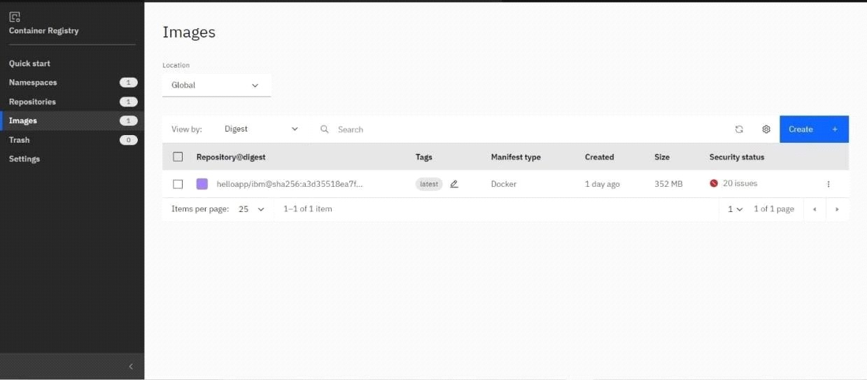

Create a IBM container registry and deploy helloworld app or jobportapp.IBM CONTAINER REGISTRY DEPLOYMENT:

OUTPUT:



Question 4:

Create a Kubernetes cluster in IBM cloud and deploy helloworld image or jobportal imageand also expose the same app to run in nodeport.

Creating kubernetes cluster in IBM cloud and exposing nodeport:

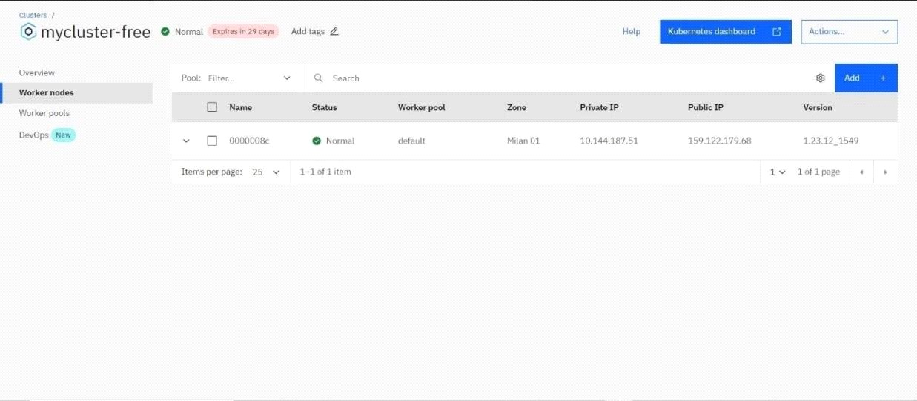

Output:

